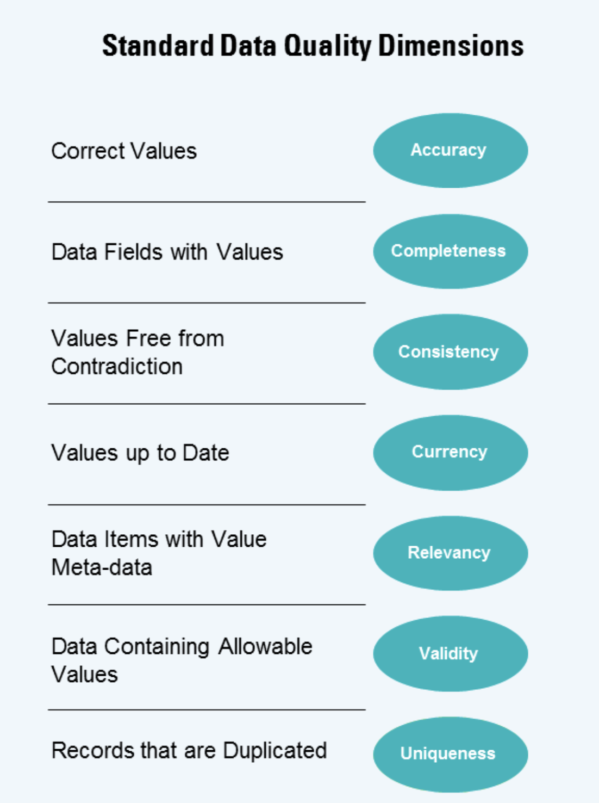

To Sprocket Central Pty Ltd,

Subject: Data quality issues and strategies to mitigate these issues.

Dear Sir/Madam

This is the data quallity issues and strategies to mitigate these issues:

1. Completeness

* In the sheet Transactions: brand, product_line, product_class, product_size, online_order, standard_cost, product_first_sold_date contain null value
* In the sheet NewCustomerList: DOB, job_title, job_title, job_industry contain null value
* In the sheet CustomerDemographic: DOB, job_title, job_industry contain null value

Mitigation: Should check null value and fullfill them.

1. Accuracy

* product_first_sold_date should change number type

1. Consistency

* Sheet CustomerDemographic → gender column → “F” and “Femal” value change “Female” value
* Sheet CustomerAddress → state column → “Victoria” change “VIC” and “New South Wales” change “NSW”

1. Currency
2. Relevancy

* Sheet CustomerDemographic → DOB contain value: 1843 → 179 years old → unrelevant

1. Validity
2. Uniqueness